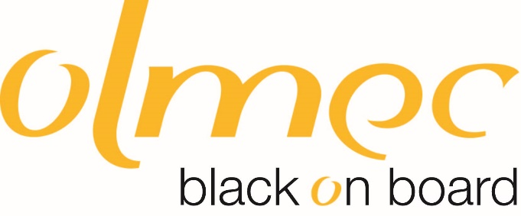

**Black on Board Community Leadership programme application form**

Thank you for your interest in this programme. We are delighted that you are applying to join the training scheme and wish you every success in your application.

Please complete this application form and send it to [info@olmec-ec.org.uk](mailto:info@olmec-ec.org.uk)

The closing date for applications is 24th November 2024.

Your referee must be your current line manager. Please be aware that if you are selected for the programme, we will contact your line manager and confirm the details with them.

|  |  |  |
| --- | --- | --- |
| Can you tell us how you heard about this opportunity? (select all that apply) | | |
| Tower Hamlets Council/Olmec website | |  |
| Intranet | |  |
| Leaflet | |  |
| Workplace | |  |
| Word of mouth | |  |
| Other (please specify) |  | |

|  |  |  |  |
| --- | --- | --- | --- |
| **PERSONAL DETAILS** | | | |
| Employee Number |  | | |
| Title | Dr/Mr/Mrs/Miss/Ms/Other: | | |
| Full Name |  | | |
| Address |  | | |
| Telephone Number |  | | |
| Email address |  | | |
| **APPLICATION** | | | |
| **What is the time commitment? We have 2 formats:**  **Option 1.** For 14 sessions over 7 months you are trained in all the key skills required from the role and legal duties of board, through to strategic and operational planning and effective decision making.  Sessions run from 10:00 am to 4:30pm  **Option 2** 10 masterclass sessions and access to online curriculum which take place from 3:00 to 5:30. Designed to minimise impact on working people whilst equipping you with the skills that you need.  The training will be delivered as hybrid with sessions in-person and online via zoom. Venue details for the in-person session taking place in Tower Hamlets | | | |
| Can you please confirm that you will be able to attend and commit to the full programme? | | | Yes / No (delete as appropriate) |
| Please tell us in 250 words or less why you are applying to join this programme? | | | |
| **REFEREE (Note this can be a Line Manager)** | | | |
| Name: | | Telephone Number:  Email Address: | |

**Black on Board Community Leadership Programme Dates**

**Timeline**

* Register your interest 30th July 2024.
* Applications Open 12th August 2024.
* Deadline midnight November 24th 2024.
* Interviews conducted throughout October and November.

**2024/25 Programme Dates**

|  |  |  |
| --- | --- | --- |
| **Session – C1** | **Date – Thursday 2024/25** | **Time** |
| 1 | November 14th | 10:00am – 4:30pm |
| 2 | November 28th | 10:00am – 4:30pm |
| 3 | December 12th | 10:00am – 4:30pm |
| 4 | January 9th | 10:00am – 4:30pm |
| 5 | January 23rd | 10 :00am – 4:30pm |
| 6 | February 6th | 10:00am – 4:30pm |
| 7 | February 20th | 10:00am – 4:30pm |
| 8 | March 6th | 10:00am – 4:30pm |
| 9 | March 20th | 10:00am – 4:30pm |
| 10 | April 3rd | 10:00am – 4:30pm |
| 11 | April 17th | 10:00am – 4:30pm |
| 12 | May 1st | 10:00am – 4:30pm |
| 13 | May 15th | 10:00am – 4:30pm |
| 14 | May 29th | 10:00am – 4:30pm |

|  |  |  |
| --- | --- | --- |
| **Session - C2** | **Date – Wednesday 24-2025** | **Time** |
| 1 | January 8th | 3:00pm – 5:30pm |
| 2 | February 5th | 3:00pm – 5:30pm |
| 3 | March 5th | 3:00pm – 5:30pm |
| 4 | April 2nd | 3:00pm – 5:30pm |
| 5 | April 30th | 3:00pm – 5:30pm |
| 6 | May 28th | 3:00pm – 5:30pm |
| 7 | June 25th | 3:00pm – 5:30pm |
| 8 | July 23rd | 3:00pm – 5:30pm |
| 9 |  | 3:00pm – 5:30pm |
| 10 |  | 3:00pm – 5:30pm |

|  |  |  |
| --- | --- | --- |
| **Session-C3** | **Date – Wednesday 24-2025** | **Time** |
| 1 | January 15th | 10:00am – 4:30pm |
| 2 | January 29th | 10:00am – 4:30pm |
| 3 | February 12th | 10:00am – 4:30pm |
| 4 | February 26th | 10:00am – 4:30pm |
| 5 | March 12th | 10:00am – 4:30pm |
| 6 | March 26th | 10:00am – 4:30pm |
| 7 | April 9th | 10:00am – 4:30pm |
| 8 | April 23rd | 10:00am – 4:30pm |
| 9 | May 7th | 10:00am – 4:30pm |
| 10 | May 21st | 10:00am – 4:30pm |
| 11 | June 4th | 10:00am – 4:30pm |
| 12 | January 15th | 10:00am – 4:30pm |
| 13 |  | 10:00am – 4:30pm |
| 14 |  | 10:00am – 4:30pm |